**Project: Use Imaging to Detect and Count Stainless Steel Flatware in a Tray**

By Don Johnson

May 3, 2004

CS 585 – Image and Video Computing

**Goal and Definition of Success**

My goad was to create a system that could count stainless steel flatware such as forks, knives and spoons in an image with the same accuracy that could be accomplished by a human inspector. The system had to be trained to recognize the items in an image, discerning them from the background material, and the object descriptors had to be persistent so that they could be used again when the system was presented with different data. The background material was a blue, surgical huck towel sitting on top of a polished, stainless steel tray.

I implemented this flatware counting system using OpenCV and C++. I used MATLAB to confirm some of my implementations of math formuli. All of my source code is in an accompanying tar ball in an Apple Xcode workspace called “Morphology” in a project called “CountObjects.”

Primary problems:

a. The objects were texture-less. I used cheaper, pattern-free silverware because I wanted to focus on morphology as opposed to texture and pattern.

b. Any keypoint/image patch approach would suffer from the aperture problem. I found out in Lab #. The SIFT algorithm was unable to create unique descriptors for the flatware. Here you see no correlation between the base image on the left and the reference image of the spoon on the right:

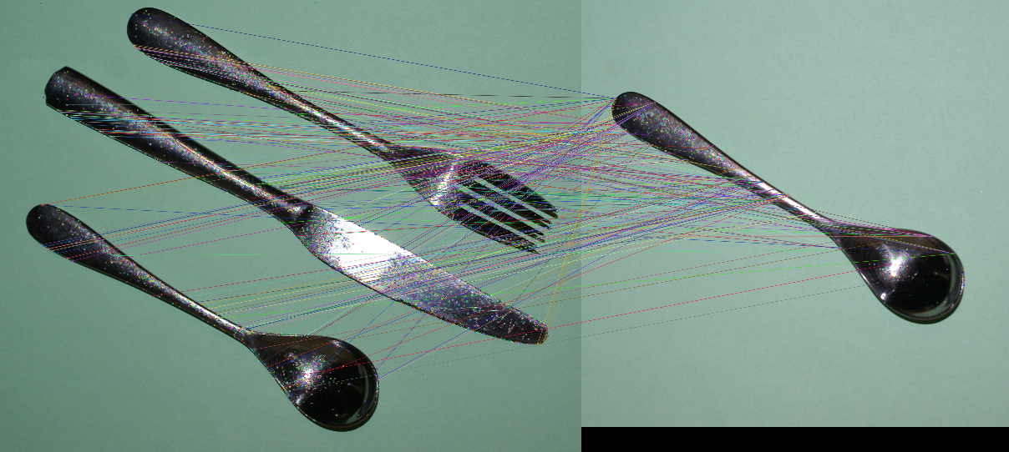

c. Working around reflections was a big problem. The objects reflected each other, the light source, and other objects in their environment. I was even surprised that reflections came from background material. Because the huck towel is porous, light from the light source reflected through it.

You can see this in the image below, in cyan pixels in the center, which represent light reflecting through the cloth:

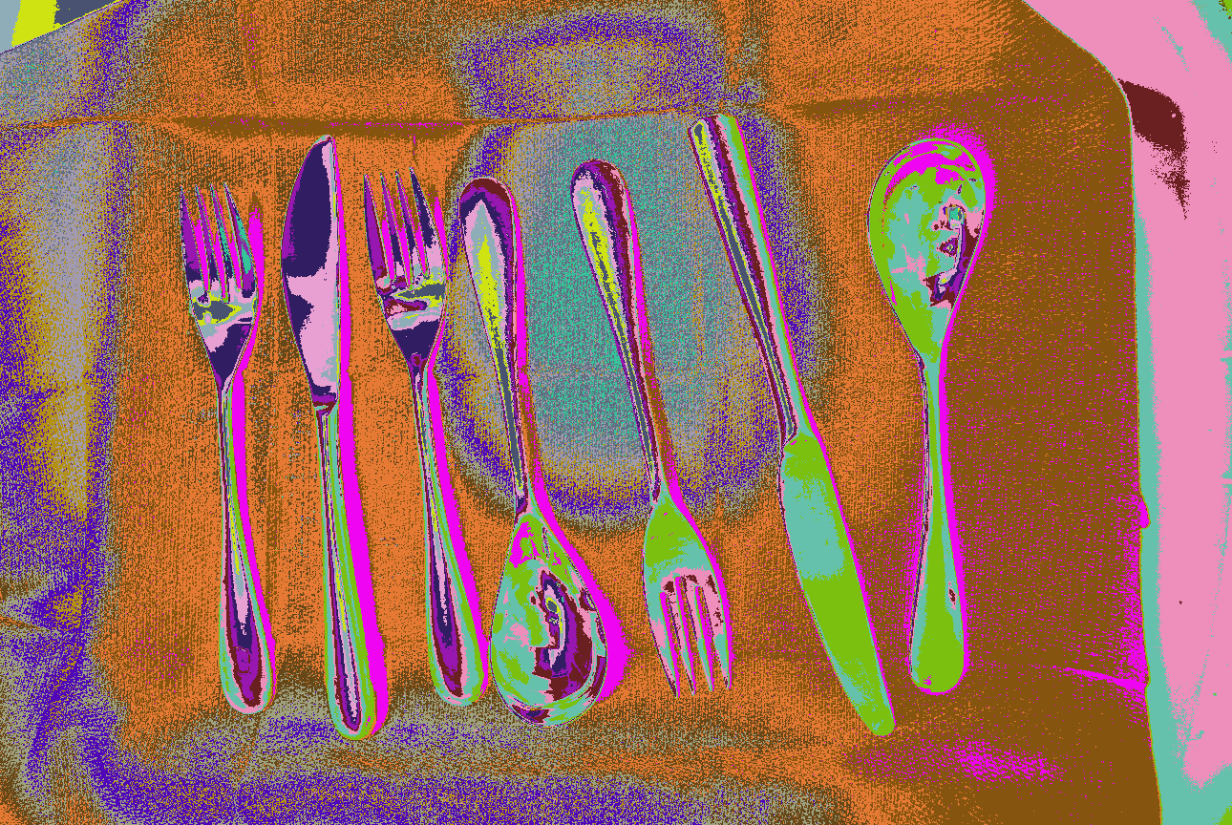

The flatware also has shadows that appear as the pink-colored pixel class adjacent to the objects.

**Data: Source and Attributes**

I created a homemade rig to hold the camera a fixed distance from the stainless steel tray covered with a blue surgical huck towel, and containing stainless steel flatware. I used an industrial hood with a halogen lamp for illumination.

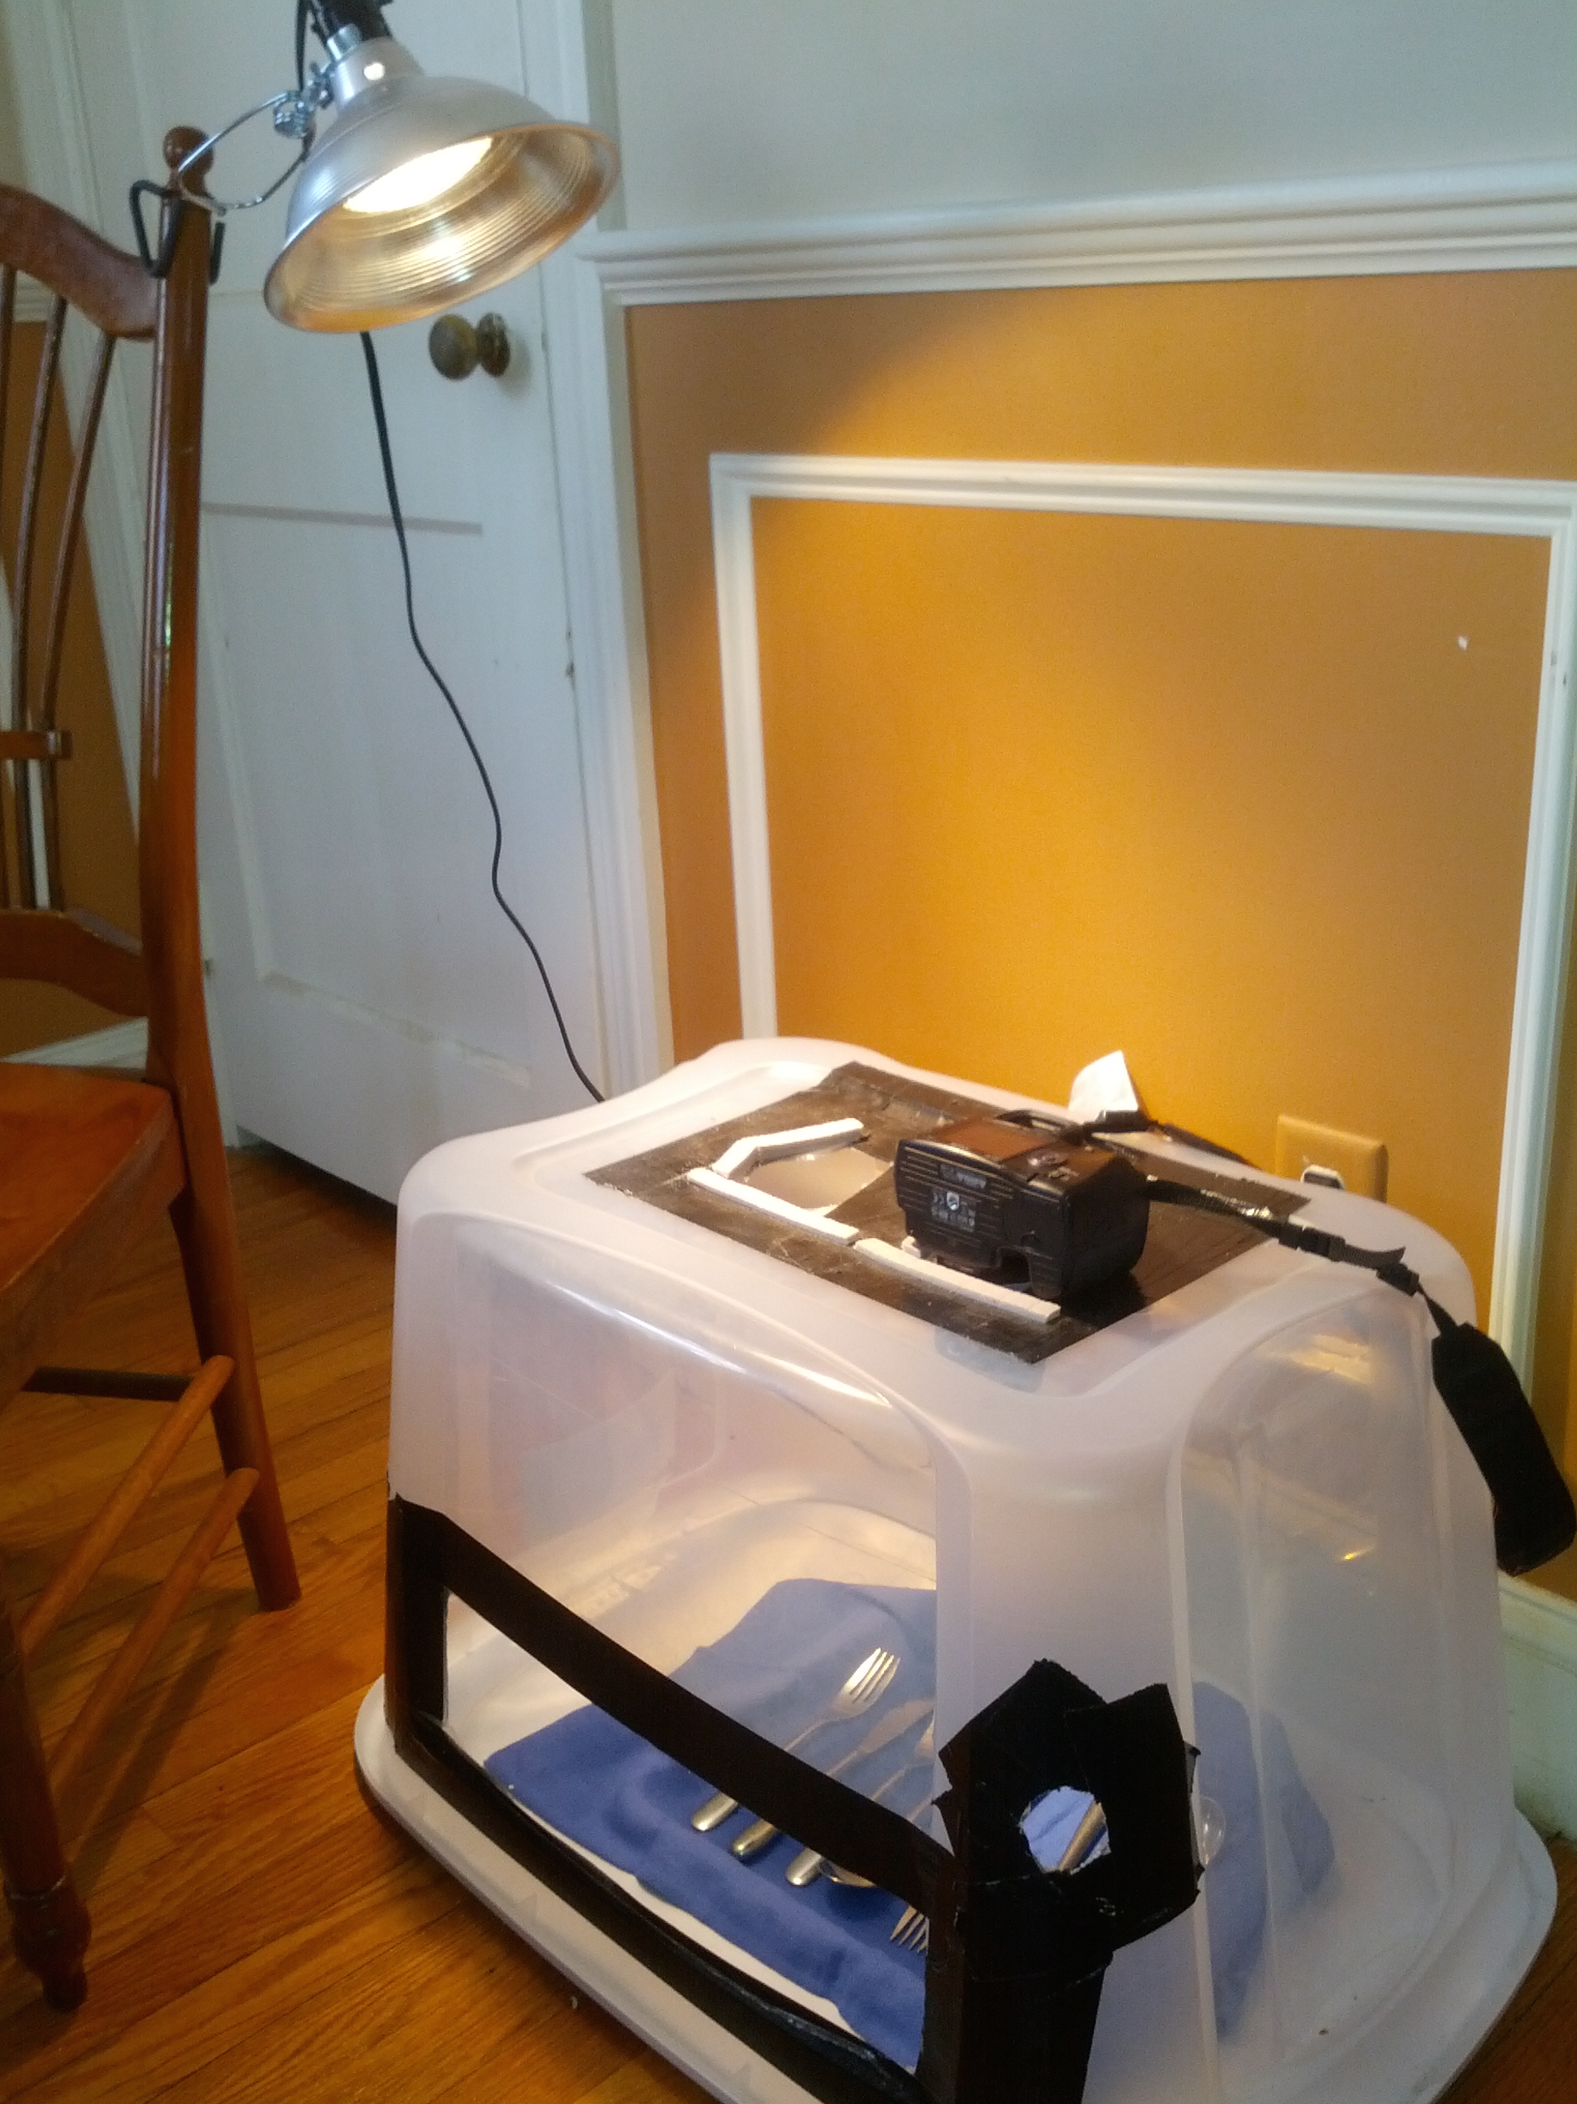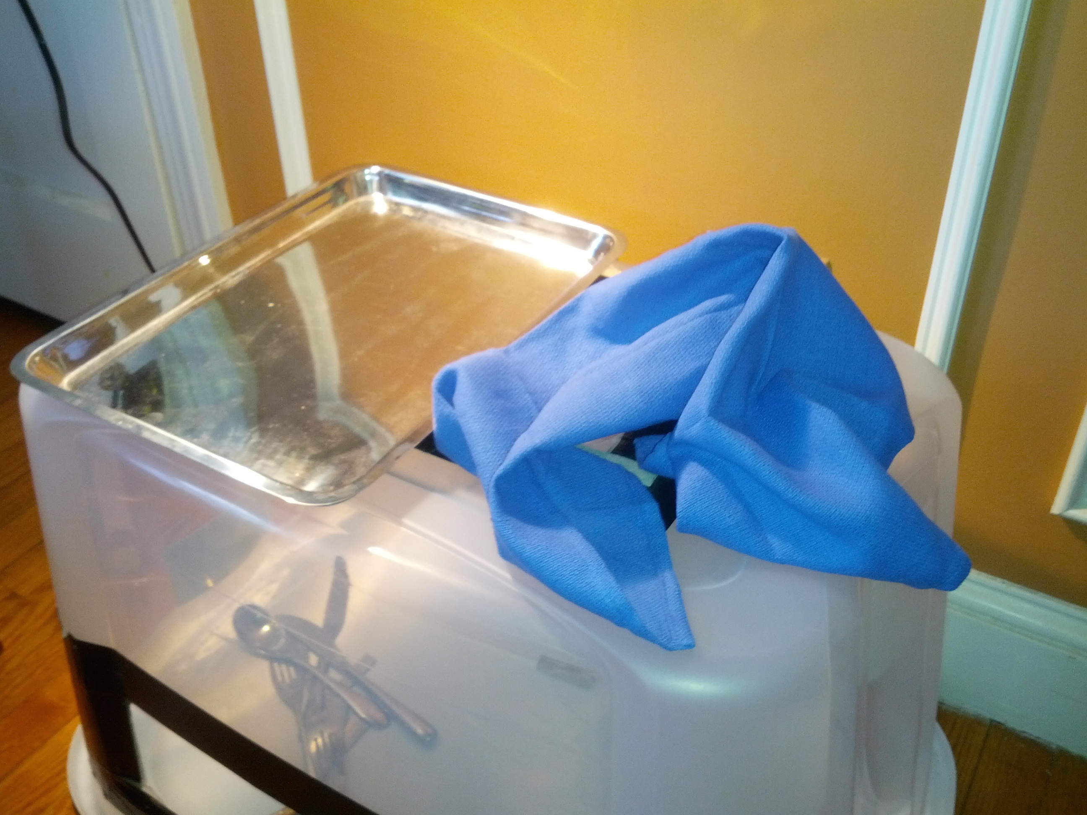

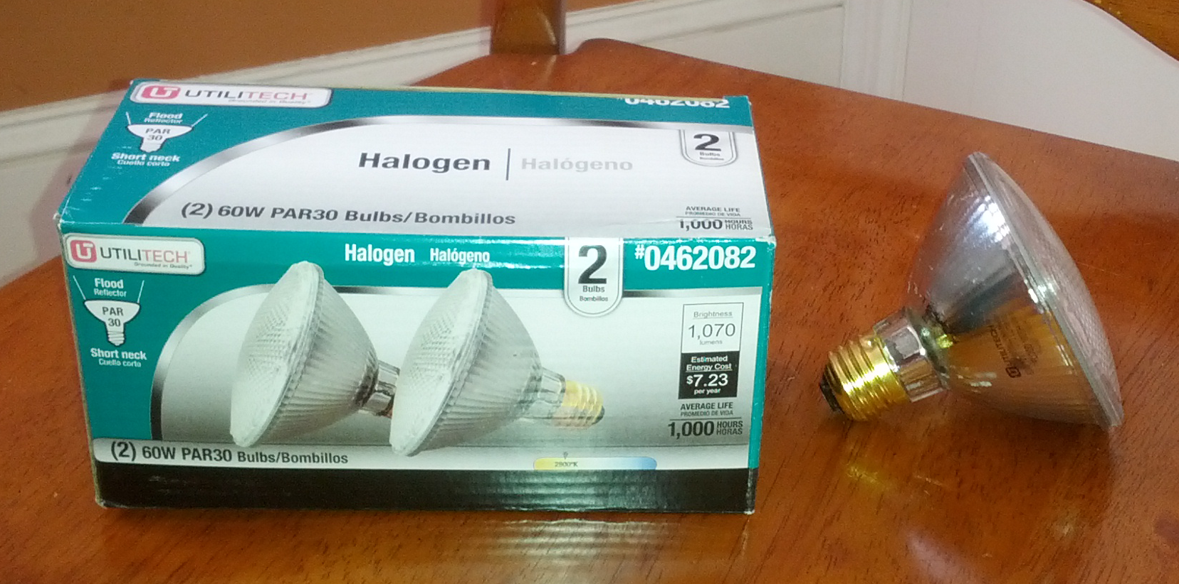

Below are sample images taken with my test rig. The top two images were taken with the halogen lamp illumination, the bottom left was taken with only daylight and the bottom right was taken with halogen lamp for illumination, but using a polarizing filter on the camera. I wanted to see if the polarizing filter would help with the reflections, but it didn’t.

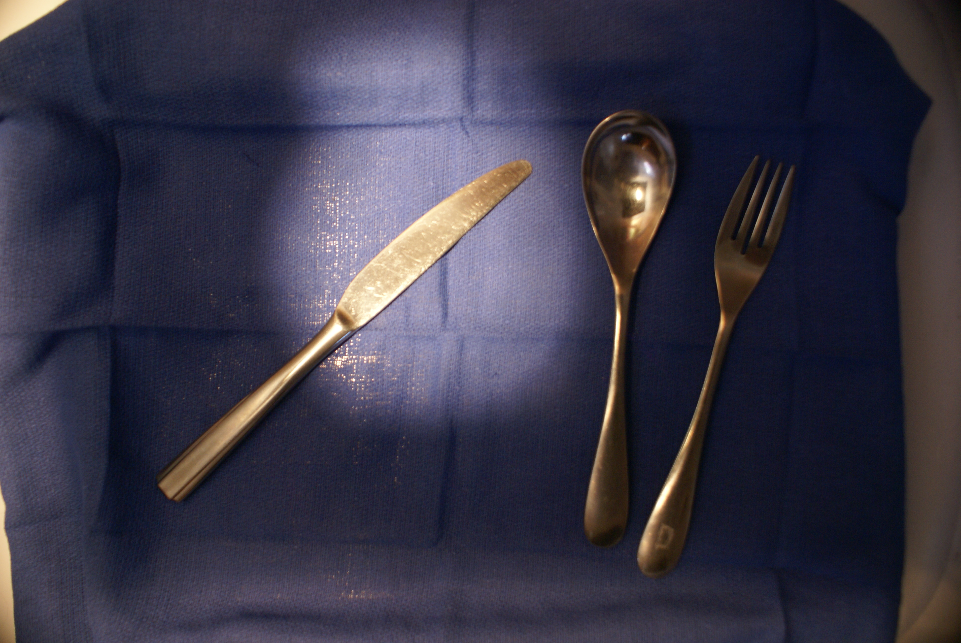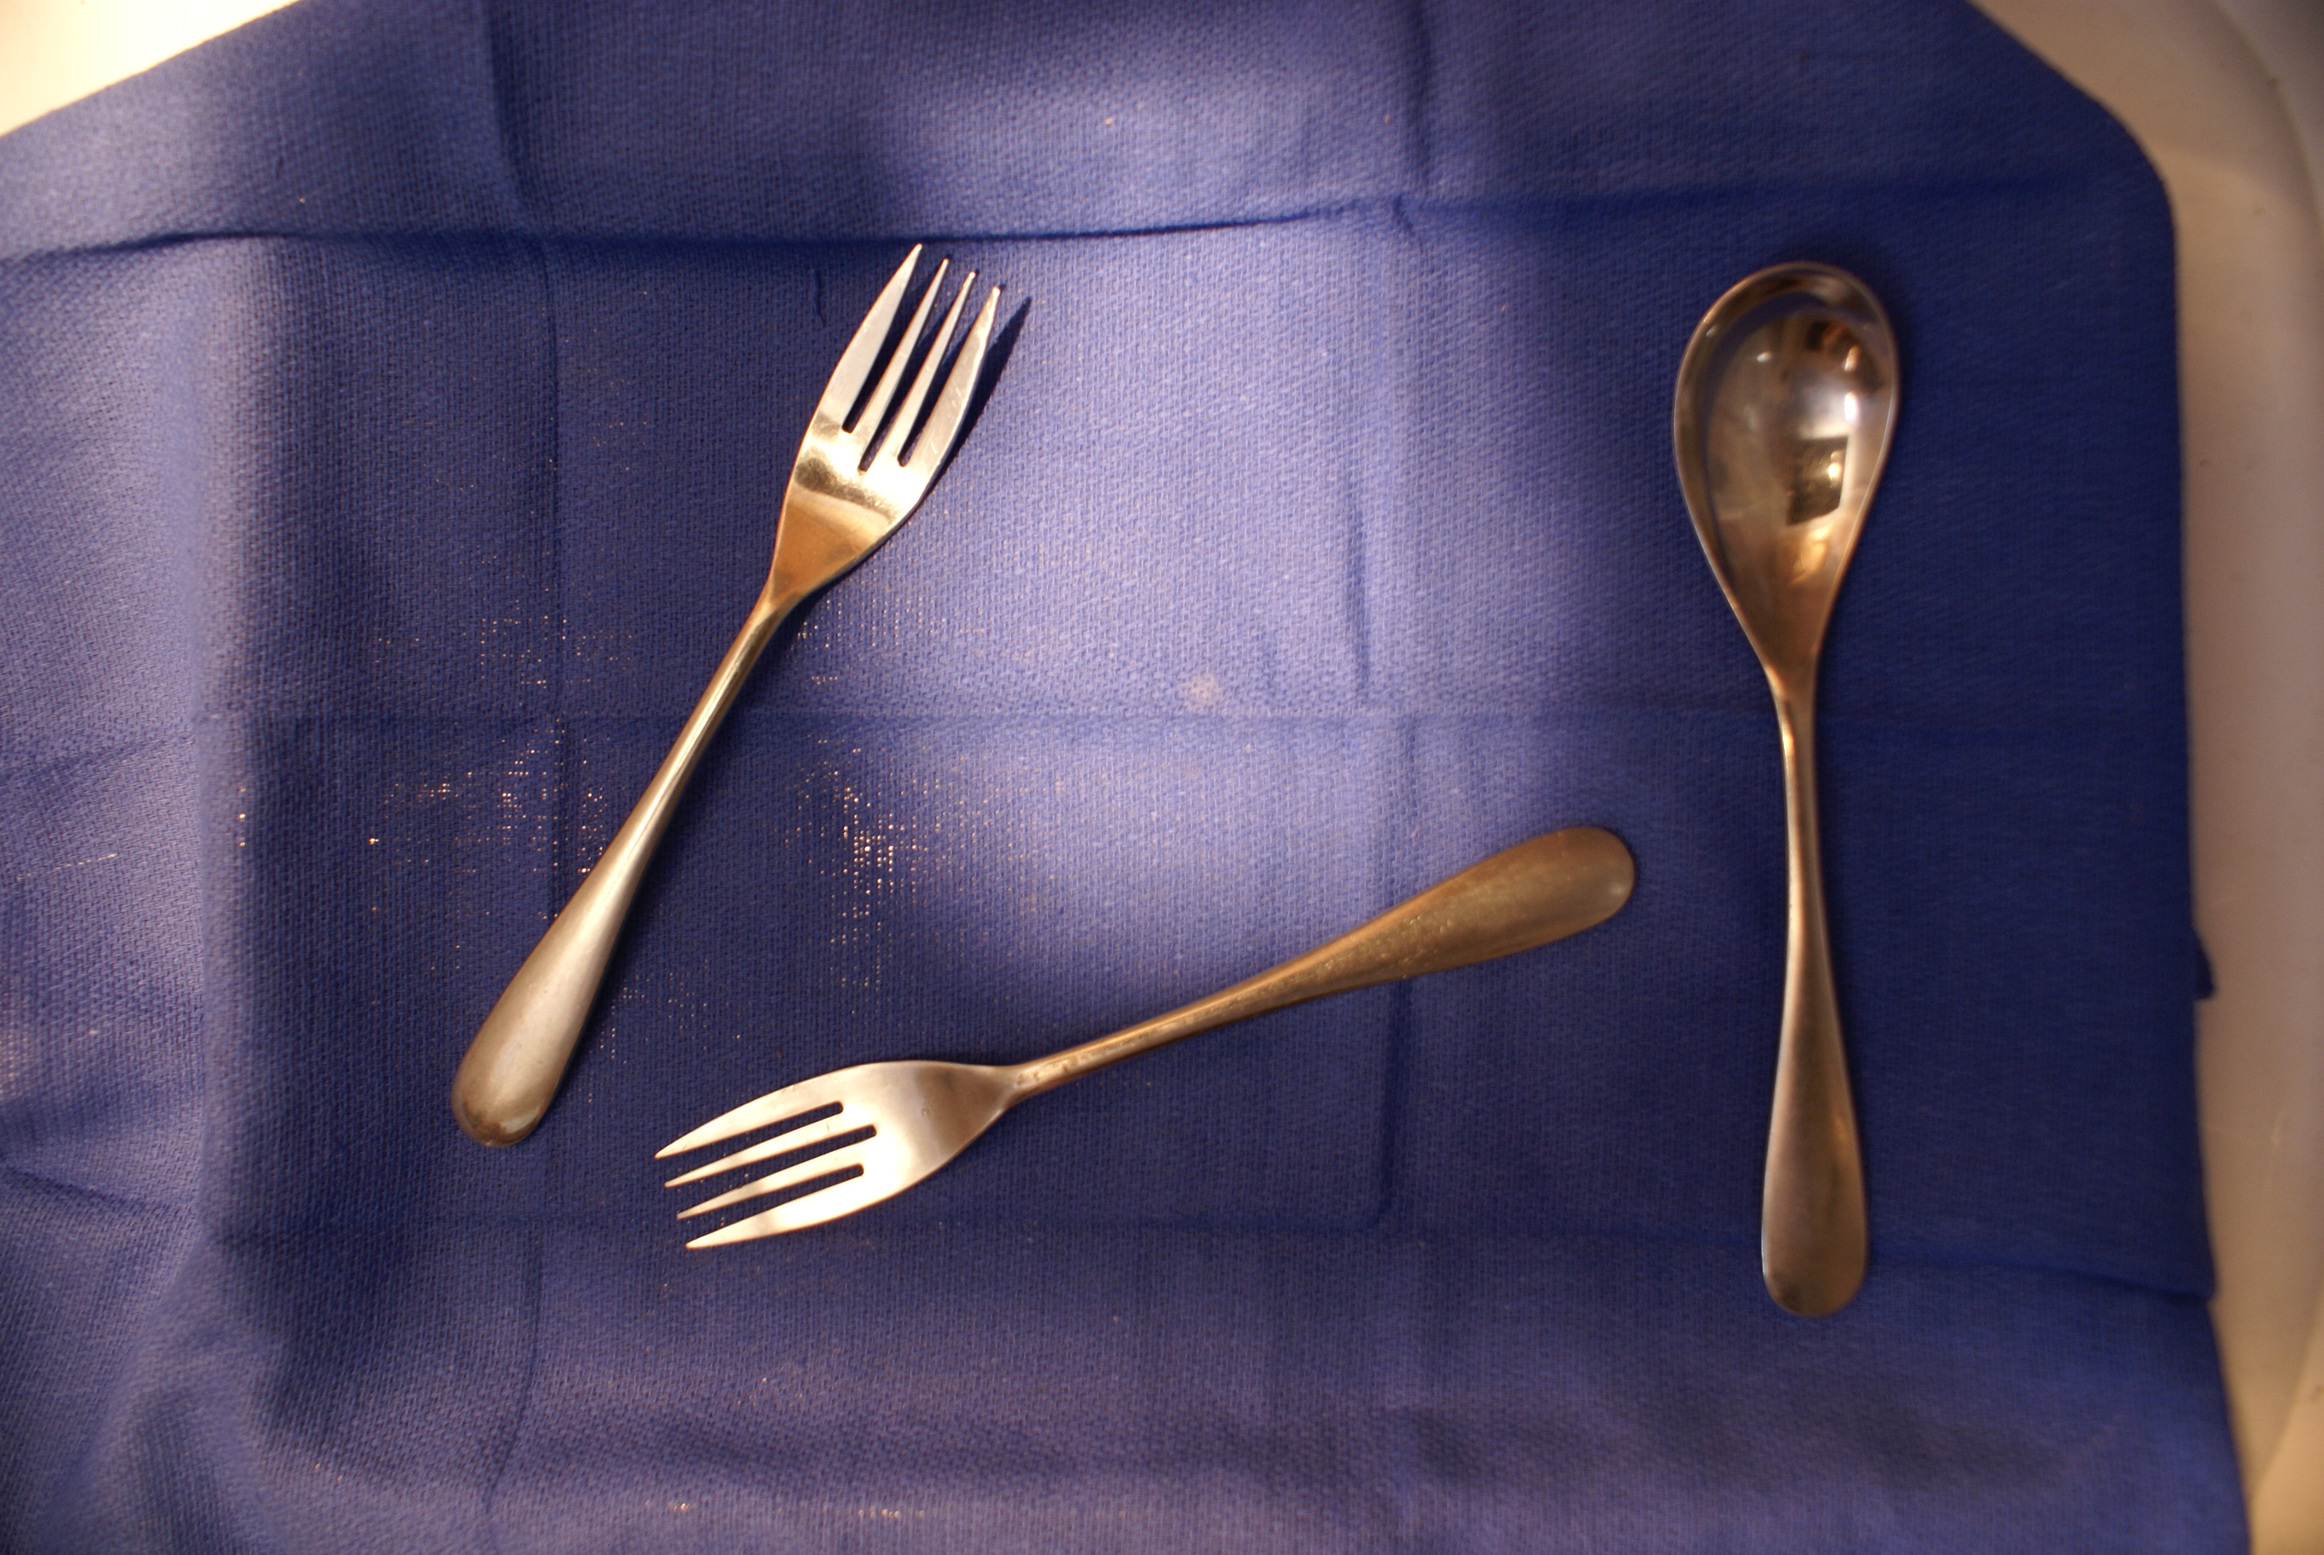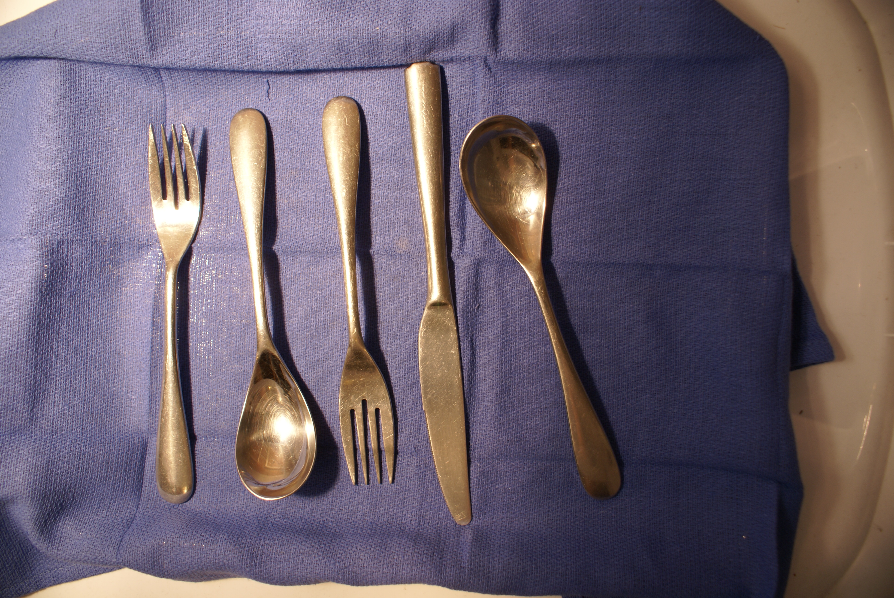

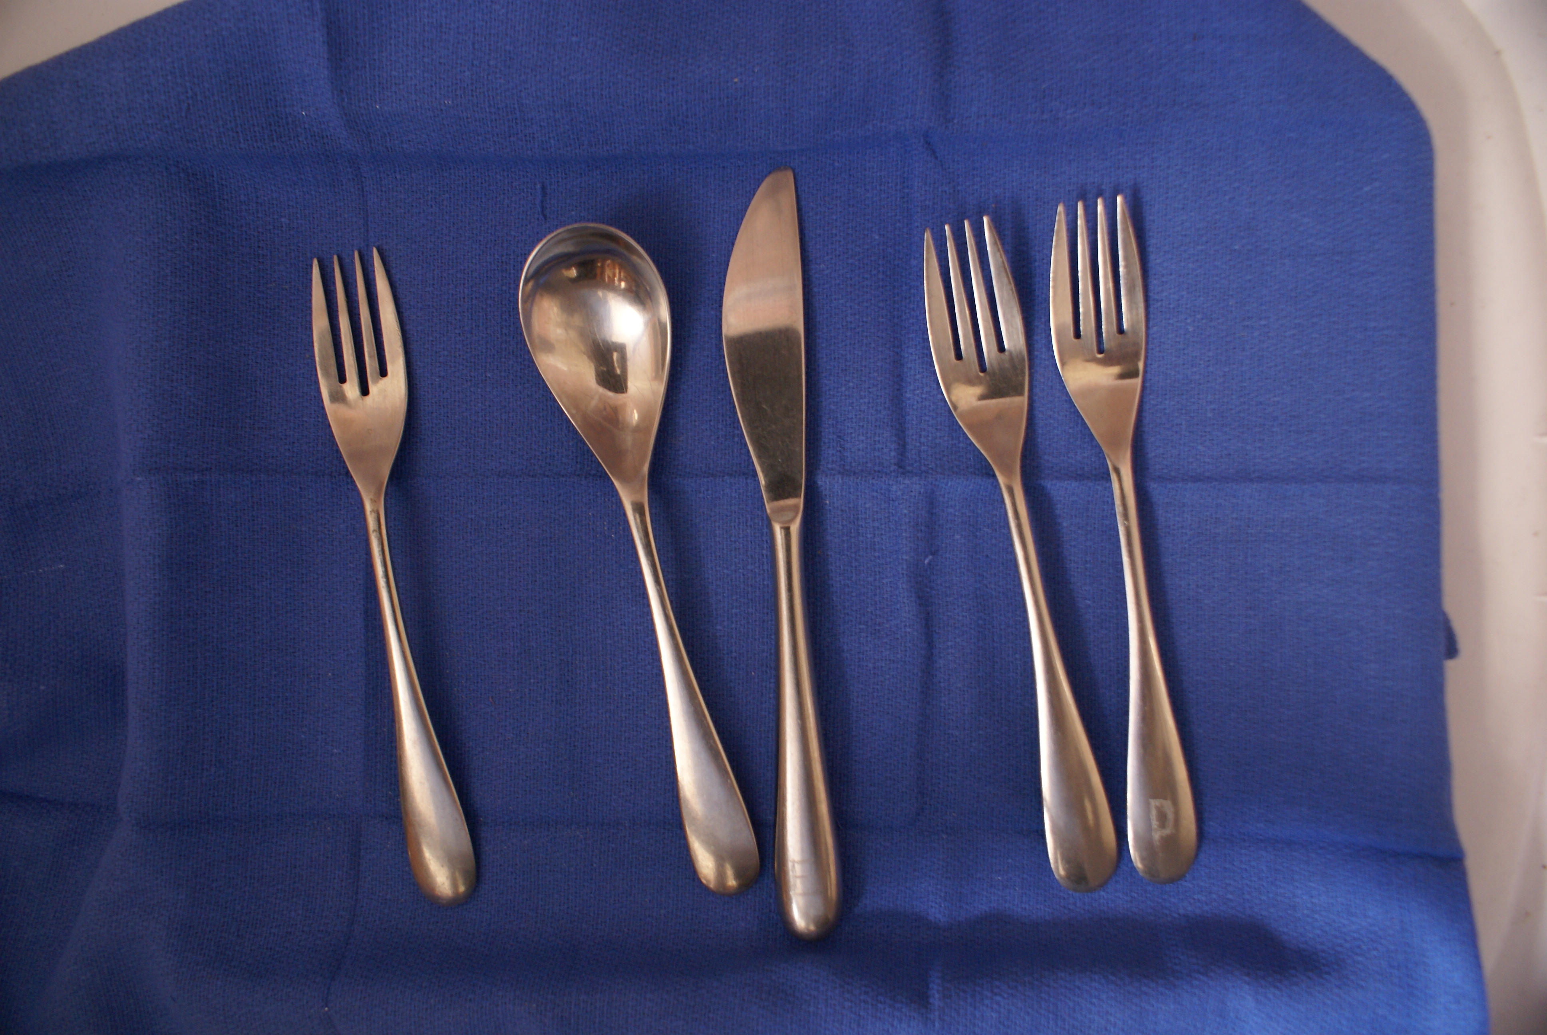

The RGB images were taken with a Sony Alpha SLR camera, downsized from the original 3872 x 2592 resolution by a factor of 4. This was done intentionally to simulate the lower resolution camera used in industrial imaging.

**Prior Knowledge**

I only little experience with object detection, recognition or tracking before taking this class. I had tried something similar to what I attempted in this project using an open source software application called, “OpenTLD.” It could not consistently detect objects like a coin, eraser, hex wrench or fingernail clipper. I didn’t realize that OpenTLD wasn’t detecting objects correctly because it was a patch-based detection system that didn’t work well on texture-less objects, and what I needed was a shape-based detection system.

**Assumptions**

I had first assumed that this task would not be too difficult because the objects had simple shapes, and I could control camera pose and lighting. I spent a lot of time floundering before I started making real progress. I did know that the project would not involve object tracking; the object inventories would be snapshots in time; Objects only needed to be detected, classified and counted. I was surprised at how difficult it was to segment the images because of the problems with reflections and shadows.

**Technical Approach**

Before I found a successful approach, I started with Canny edge detection. The reflections in the flatware created artificial edges. There were also gaps that couldn’t be closed with simple dilation. Next, I worked with the canned segmentation, like the Fiji’s level-set, active contours plugin. The contours either flowed over object edges or got stuck at suboptimal, background boundaries. I also thought that detecting and counting corners would be very useful in classifying the flatware. However, OpenCV’s Harris-Stephens corner detection either detected false corners, or missed significant corners like the ends of the tines on the forks.

These failures led me to the conclusion that I had to use a more fundamental approach. I tried different color spaces to achieve better separation between object and background and settled on YCrCb. I us k-means clustering to operate on the YCrCb image creating classes of super-pixels: bright reflections, shadows, and other aspects of the background and foreground objects. I remove the background, do a morphological close, and run a flood fill to identify the blobs. I calculate a descriptor for each blob using Hu Invariants, area, and contour length. Lastly, I count the classified objects. This is a high level description and to provide more details, I created a flow chart of this object counting application that appears exhibits section.

The application actually has two modes: a calibration mode and an automated run mode. During the calibration mode, used on only the first image in a sequence of images, the user defines the background classes by clicking on the super pixels associated with them. The automated runs then use the saved classification centers, color palette and background classes on the remaining images. The user sees an image like the one on the next page during calibration. The program accepts and input and output file name, state flag (true=calibration, false=automated run) and the number of desired pixels classes to be output from the k-means clustering process.

**Exhibits: Math Formuli, Sample Descriptors and Detailed Flow Chart**

Math Formuli

*Intensity, scale, and rotational invariant Hu’s moments*

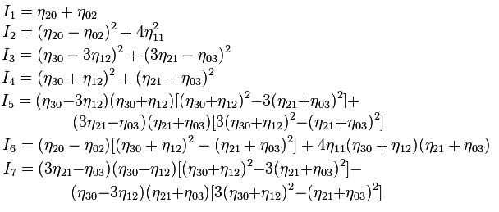

*Compactness = Area / Contour Length*

**Sample Descriptors**

|  |  |  |  |  |  |  |  |  |  |  |  |
| --- | --- | --- | --- | --- | --- | --- | --- | --- | --- | --- | --- |
| **Object** | **Hu Invariants** |  |  |  |  |  |  |  | **Area** | **Perimeter** | **Compactness** |

**Additional problems**:

a. Occlusion is the most difficult problem. Objects underneath other objects will be difficult to count. The may be more than even two layers of objects. Each count for a class of object (e.g. forks) must have an associated probability and confidence interval as opposed to an absolute count.

b. I will include some calibration scale on the surface holding the objects so size and number of pixels can be correlated. However, the objects will have to be registered because then can be rotated and translated in any way. When we start piling them up, they can also present an oblique view to the camera if they are not laying flat, but propped up at an angle to the image plane by other objects underneath.

c. Change the background to a reflective surface to see if the reflections can be filtered out of the image.

d. Add forks with flat tines and see if they can be distinguished from forks with curved tines. This may necessitate using stereoscopic images.

**Source of data**: Images taken myself with a Sony SLR.

**Algorithms**

Assume every operation performed on the image data has already been done to the training data, labeled and stored in a database in some type of descriptor

**Machine Learning**

Might want to create n-dimensional descriptor based on output of Stages 1, 2 results and use k-means clustering to classify objects.

**Stage 1 Classification base on blob characteristics**

Distinguishing objects: use MISR to detect blobs. Calculate area, perimeter, elongation, and compactness and circularity. Normalized pixel count via calibration scale before doing calculation. Create a correlation matrix between training set values and detected values for blob. Calculation probability that each blob is each respective object in training set

Anything not having close correlation to some set of blob characteristics is probably a “combined” object because of occlusion. Set the object(s) aside so the parts can be separated and re-input in the analysis process.

**Stage 2**

Detect edges using Canny.

Do a closing operation and/or Hough transform

Do contour matching.

Using Szeliski Ex 4.9

Walk contour and create list of (xi, yi, si) triplets using arc-length formula for si.

Resample list onto a regular set of (xj, yj, sj) using linear interpolation

Compute x, y averages and subtract from all triplets.

Resample piecewise-linear function onto length-independent set of samples

Compute Fourier transform of curve treating each (x,y) pair as complex. This decomposes each curve into a set of coefficients representation each curve as a linear composition of sinusoids (pretty cool!). The descriptor stored in the database will be the number (order) and magnitude of the coefficients. Have to come up with some “fuzzy” way of correlating the descriptors. The coefficients will be rotation, translation and scale (?) invariant. They will not be invariant for items that are not orthogonal to the camera optical axis. Don’t know what to do about that.

Also, will classify based at sharp and rounded corners: top of tines on a fork, tip of a knife and the bottom and top of spoon.

**Stage 3**

Work on occluded composite objects remaining from Stage 1 analysis.

Iterative process

Use spline and/or snake to fit curves to lines in object. Look for closed blobs in object and remove one.

Feed blob back into Stage 1; check for match. Next, feed it to Stage 2 and look for partial match base on curves.

Repeat by removing next blob in object.

For example, say a fork is lying on top of a spoon. It will be extracted as a blob, fed back into Stage 1 and 2. Stages 1 and 2 will be identifying it as a fork. Now, you will be left with two pieces of a single spoon with a section missing where the fork was. Individually, the spoon pieces will fail to match anything in Stage 1, but both pieces will have some curve matching in Stage 2. You might also be able to do some region merging and come up with a blob that will be matched by feeding it back into Stages 1 and 2.

**Stage 4**

Create confusion matrix from having human do actual count and analyze results. Refine algorithms and/or classification scheme.

**II Goal**: Tracking and classifying tropical fish

I think that detecting motion, analyzing color and texture would be very important in tracking and classify tropical fish.

Even when the fish are sleeping, the fins flap to maintain equilibrium. I would analyze the frequency and even look at the probability distribution function with respect to time of the fin motion. This distribution would be different that the rhythmic waving on plants in water current.

Detecting blobs in all three color spaces and looking at color composition and ratio could help classify the type of fish.

SIFT would also be useful as long as you could extract “good” images in a video sequence where the fish was swimming perpendicular to the camera axis. This would generally be when the blob area was largest in the sequence. Optical flow techniques could be used because swimming patterns might be distinctive for different type of fish.

**III Goal**: Detect people who are not wearing their seat belts and use the results of someone else’s license plate detection process to send the scofflaws a very expensive ticket. This is Massachusetts after all.

Camera position would be very import because the best perspective would be straight on through a windshield.

First, I would use Viola-Jones, Haar filter to detect the face. I would use the face, and bridge of the nose to come up with an orientation line and centroid.

Next, I would look under the face for contour of the shoulder. Finally, relative to face and shoulder, face centroid and orientation line, I would look for angled parallel lines representing the presence of a safety belt.